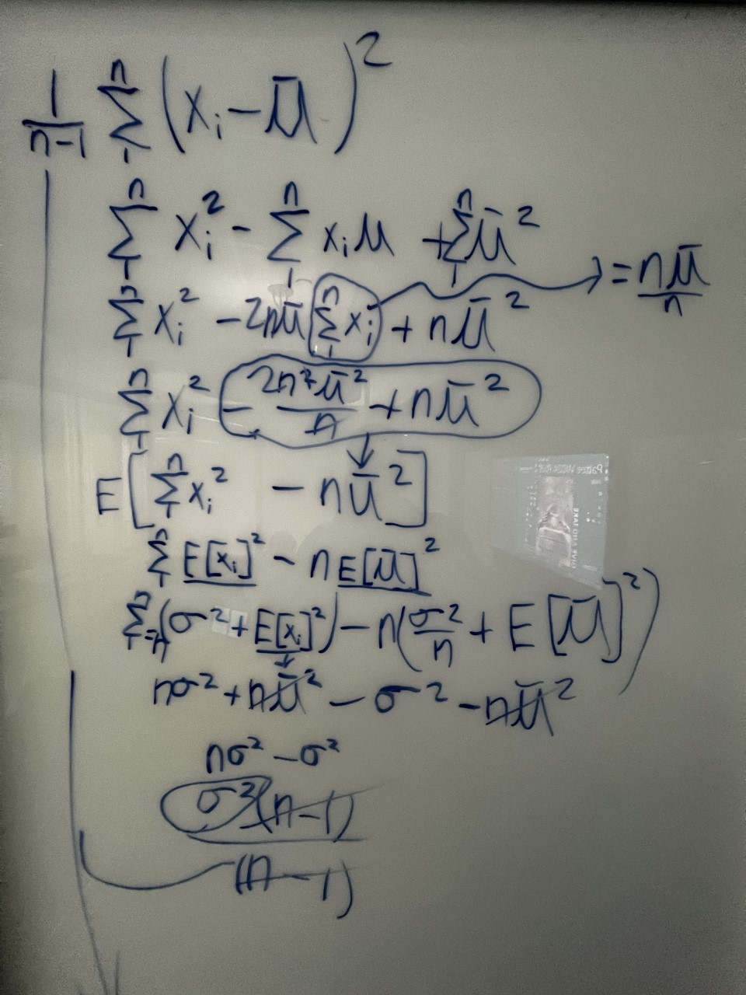

1. Text, letter

   Description automatically generated
2. 